Tokushima Prefecture Disaster Prevention Center Study Tour
The importance of preparing for the Great Nankai Trough Earthquake expected to hit Tokushima is only increasing. If the earthquake occurs, what will you do?
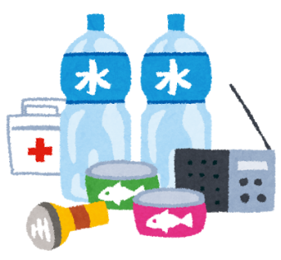
Tokushima Prefecture Government, in conjunction with the Tokushima Prefecture International Exchange Association (TOPIA) is proud to announce a study tour for foreign residents at the Tokushima Prefecture Disaster Center to provide information on what to do in case of a natural disaster.
During the tour you can experience earthquakes, strong winds and more via simulation, as well as learn about what to do when a disaster occurs.

Date： September 11th, Sunday 13：00～15：30
13：00 – Leave Tokushima Station by bus for the center
15：30 – Arrive at Tokushima Station by bus
Location： Tokushima Prefecture Disaster Center (Kitajima-town, Tainohama Aza Onishi 165)
Target： Foreign Residents in Tokushima Prefecture
Details： Disaster prevention guidance via video, simulation of strong winds / earthquakes, fire fighting and disaster control exercises (English and Chinese Interpreting)
No. Places： 30 people
Cost： Free
Applications： Please fill out the below and send in by fax to the address at the bottom of the form.
You can also apply by sending the same information by email or postcard.
Deadline: Sep 8th, Thursday

Name |  |  |  | Gender | M ・ F
Address
TEL |  | Nationality
E-Mail Address
Occupation

Applications to:
FAX: （088）652-0616
Email: coordinator1@topia.ne.jp
Postcard: 〒770-0831Tokushima-shi Terashima Honcho Nishi1-61 Clement Plaza 6F
Koekizaidan Hojin Tokushima-ken Kokusai Koryukyokai (TOPIA)
Contact: Ms. Kimura at TOPIA TEL（088）656-3303

